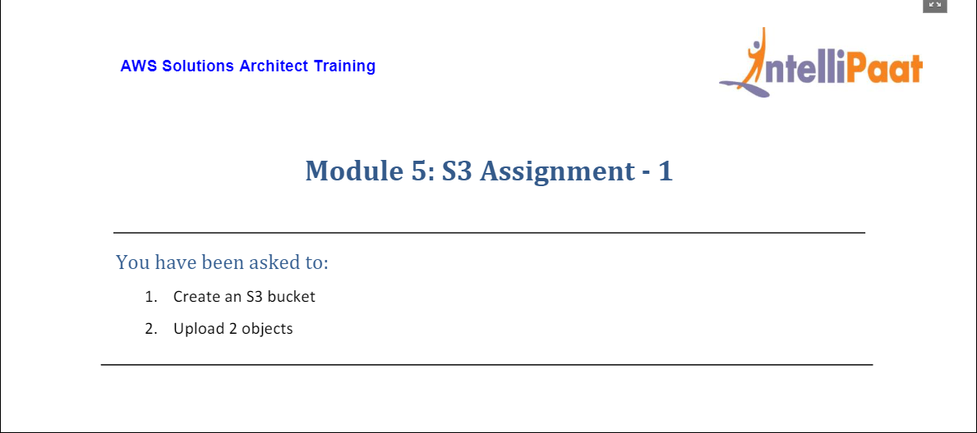

* Created a S3 bucket named ‘**mod5assignment1**’.

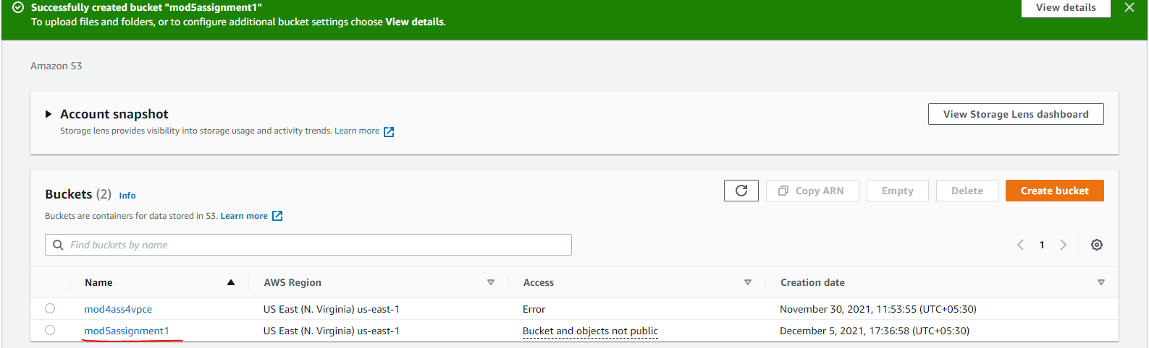

* Uploaded two objects in it – ‘**Object1**’ and ‘**Object2**’.

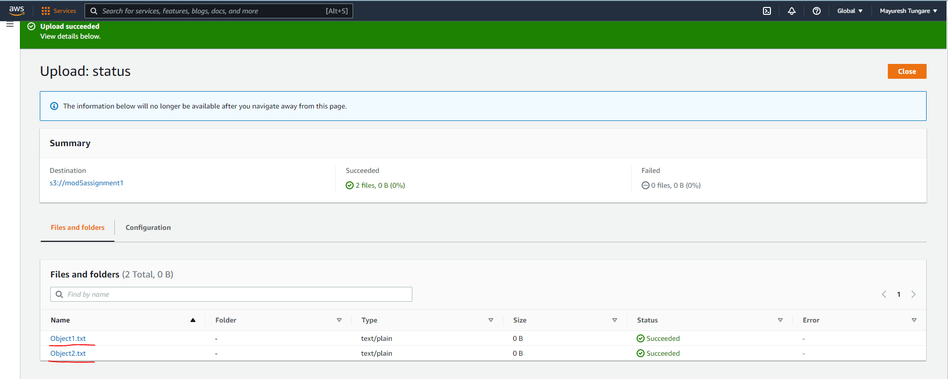

The assignment is now complete.